 |  | Online Physics for Teachers
 |  | Hands-On Distance Learning Courses for Elementary and Middle School Teachers
 |  | The Online Courses
 |  | 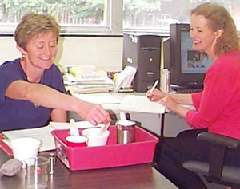  Hands on activities for Science teachers |  |  | What we offer: Science courses based on engaging activities that you can use in your own classroom, delivered in a online format. You work at your own site, and at your own pace. An equipment kit is provided.  Who it is for: Elementary and middle school teachers who want to learn more about physical science, either for course credit or professional development.
 |  | 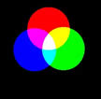 | Light Course: | The light course consists of 9 units designed to encourage exploration of the various principles of light including shadows, the spectrum, prisms and mirrors. It's colorful! See more!
 |  | 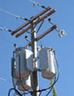 | Electricity and Magnetism Course: | The electricity and magnetism course consists of 10 units with activities to investigate fluids, current, resistance and circuitry. It's electrifying! See more!
 |  | 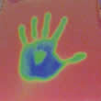 | Temperature and Heat Course: | The temperature and heat course consists of 10 units with hands-on activities to explore thermal expansion, liquid crystals, and thermal conduction. It's hot stuff! -- and pretty cool! See more!
 |  | 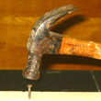 | Force, Motion, and Energy Course: | The force, motion, and energy course consists of 10 units with hands-on activities to explore force, acceleration, and aspects of energy. A moving experience! See more!

How these courses work
Our courses are specifically designed for inservice teachers in all grades, with our main target being grade 4-9 teachers who want to know more about physics or would like activities they can use to teach it. They are inquiry and standards-based and can be taken by individuals or a small group (2 or 3 works best). All work is done at your own site, on your own schedule. The courses don't assume any previous science or mathematics. They are "conceptual" courses, which means that you learn how the world works in English, instead of in Mathematics. The courses are asynchronous: you start anytime -- now, for example!
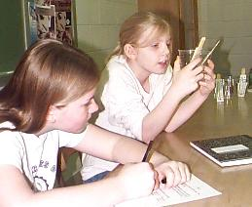
The courses were written with the middle school science teacher in mind; they cover the core content for those grades, and make use of activities that can be imported into the middle school classroom with minimal modification. For use in the elementary classroom, you would want to emphasize what happens, rather than why it happens; there are still some interesting and fun activities for you to use. Take a look at the sample pages, to see what we mean.
Each course takes between 30-45 hours to complete.
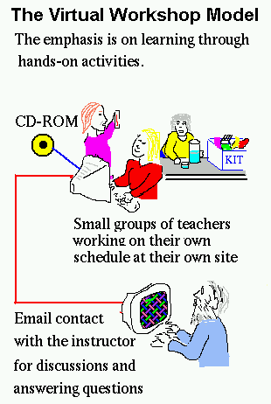
Here is how this works: we send you a "teachers kit" containing the various science tools you will need to do the activities; a CD; and a blank journal. The CD contains a bunch of web pages that you can access with Internet Explorer or however you get to the internet. You work from the CD, which is the textbook and virtual professor; the course is largely based on hands-on activities. At specific points (or whenever you feel like it) you communicate back and forth with us via email.
There are 8 to 10 sections depending on which course you choose. As you will see from the preview versions, each section on the CD contains exploration activities for you to do, then a few in-depth activities, followed by some science background information to help you understand the content behind what you have just done. The section concludes with a set of discussion questions from which your group (or you if solo) chooses some to discuss with us via email by sending us a couple of paragraphs for each question. We'll answer back (usually within 24 hours; a lot faster if we know when the message is coming) so we'll have a dialog. These discussion questions take the place of the face-to-face dialogs we would have with you in person. That's where we learn what your understanding and/or misconceptions are, and where we lead/push you to greater understanding.
Meanwhile, the CD also tells you at which points to record things in your journal. Your journals become your own reference tool to remember what you did in the course. We'll ask to see these at the end, but will return them right away to you. There are also pre- and post- course written assessments.
The activities in the courses are inquiry based -- you discover the laws of nature instead of being told them -- and are readily adapted for the middle school classroom. In fact, we also offer classroom sized kits for purchase after the workshop/course so you can immediately implement what you learn in your own teaching.

For more information:

Joseph P. Straley
Department of Physics
University of Kentucky
Lexington, KY 40506-0055
(859) 257-3197
sciworks@pa.uky.edu

The Light Course
 | 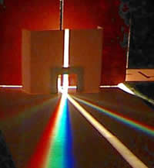 | There are 9 units, as described below. Each unit starts with an exploration (simple qualitative investigations) of the subject of the unit, followed by two activities (more formal investigations, frequently having a quantitative component). The sections "About ..." are a few pages of text and pictures explaining the relevant scientific concepts. The final section "Discussion of ..." presents some questions for the participants to discuss. They email their discussion to the workshop instructors. In addition, many sections have an additional page "Why study (the subject of this unit)?"
Here are the activities of the workshop. Links are given to some sample pages.
- Shadows
Exploring shadows; Some shadows are sharp, and some are fuzzy; Making a shadow of a certain size; How tall is the flagpole?
Why study shadows? Examples and motivation for this section
- Spectrum
Exploring diffraction gratings; Different kinds of lights; Making a spectroscope
- Color
Exploring color;Subtracting colors; Adding colors
- Light beams
Making and exploring a light beam; Color filters and diffraction gratings in a light beam
- Flat Mirrors
Exploring a mirror; What path does reflected light follow? Mirrors in the light beam
- Refraction: Prisms and Lenses
Exploring prisms and lenses; Prisms and lenses in a light beam; A simple microscope.
- Curved mirrors
Exploring curved mirrors; Curved mirrors in a light beam; An optical toy, based on a curved mirror
- Images
Exploring images; Do lenses make more than one focused image? How big is an image? Discussion questions for this section
- Light energy
Exploring light energy; Glow-in-the-dark paper Light energy and heat energy
- Summary of the workshop

The Course on Electricity and Magnetism
 | 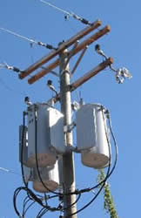 | There are 10 units, as described below. Each unit starts with an exploration (simple qualitative investigations) of the subject of the unit, followed by two activities (more formal investigations, frequently having a quantitative component). The sections "About ..." are a few pages of text and pictures explaining the relevant scientific concepts. The final section "Discussion of ..." presents some questions for the participants to discuss. They email their discussion to the workshop instructors. In addition, many sections have an additional page "Why study (the subject of this unit)?"
Here are the activities of the workshop. Links are given to some sample pages.
- Fluids
Exploring flowing fluids; Siphons
- Current
Batteries, motors, and light bulbs; circuit diagrams; current direction; making a switch and socket. Science content: about electrical current
- Direction of electrical current
- Batteries and capacitors
Conductors and batteries; capacitors; light-emitting diode; making a battery
- Concepts of electricity
A recapitulation of the topics of the first four units. (This is the first unit of the second module)
light-emitting diode, capacitors
- Resistance
Conductors and insulators; resistors; resistors and capacitors
- Circuits
Series circuits and parallel circuits
- Magnetic field
Compass; Magnetic field; Mapping the magnetic field
- Magnets
Magnets; interaction of magnets; Range of the magnetic force; Behavior of iron
- Electromagnetism
Currents and magnets; Making an electromagnet; Making a motor; Inducing a voltage

The Course on Temperature and Heat
 | 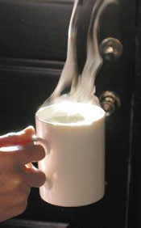 | There are 10 units, as described below. Each unit starts with an exploration (simple qualitative investigations) of the subject of the unit, followed by two activities (more formal investigations, frequently having a quantitative component). The sections "About ..." are a few pages of text and pictures explaining the relevant scientific concepts. The final section "Discussion of ..." presents some questions for the participants to discuss. They email their discussion to the workshop instructors. In addition, many sections have an additional page "Why study (the subject of this unit)?"
Here are the activities of the workshop. Links are given to some sample pages.
- Temperature
- Thermal equilibrium
Exploring thermal equilibrium; Equilibration of things initially at different temperatures
- Thermal expansion
Why study thermal expansion?
Exploring thermal expansion; Making a temperature sensor
Making a thermometer
- "Liquid crystal" thermal sensing sheet
Why study thermal sensing sheet?
Exploring "Liquid crystal" thermal sensing sheet; Calibrating the liquid crystal
- Thermal conduction
Why study thermal conduction?
Is glass cool? Is fur warm? (Exploration of thermal conduction); How long does your drink stay hot? Find the conductor (a puzzle based on thermal conduction)
- Convection and Radiation
Why study convection and radiation?
Exploring convect
- Conversion of other forms of energy into thermal energy
Exploring energy conversions; Different methods to transfer heat; Does color affect how materials absorb heat?
- Phase change
Why study phase changes?
Exploring change of phase; What happens when water evaporates? What is the temperature pattern of ice water as the ice melts?
The discussion questions page for this unit
- How temperature and energy are related
Why study thermal energy?
Exploring thermal energy; Calorimetry 1: If two objects are at the same temperature, do they both contain the same amount of energy? Calorimetry 2: Sharing heat among different objects; Calorimetry 3: Effect of using different materials
- Irreversibility
Mixing and unmixing (exploration of irreversibility); How many combinations? Flipping a coin: random and uncorrelated events; A model for equilibration

The Course on Force, Motion, and Energy
 | 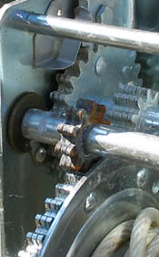 | There are 10 units, as described below. Each unit starts with an exploration (simple qualitative investigations) of the subject of the unit, followed by two activities (more formal investigations, frequently having a quantitative component). The sections "About ..." are a few pages of text and pictures explaining the relevant scientific concepts. The final section "Discussion of ..." presents some questions for the participants to discuss. They email their discussion to the workshop instructors. In addition, many sections have an additional page "Why study (the subject of this unit)?"
Here is an outline of the activities of the course, and a few sample pages.
- Timing
Learning how to use the stopwatch, and how deal with measurement errors
- Force
Measuring force; interacting systems; Newton's Third Law
Science Content: Force
- Balanced forces
Static equilibrium
- Force and energy
Energy and levers
- Uniform motion
Newton's First Law
- Acceleration
Acceleration in one dimension. Acceleration involving change of direction of motion.
- The law of force and acceleration
Newton's Second Law
Why Study The Law of Force and Acceleration?
Rolling Race
- Potential energy and kinetic energy
Magnet launcher
- Friction
- Vibration

