**Physics Petting Zoo can visit your school**.

The Physics Department at the University of Kentucky has received a small grant from the Division of Condensed Matter Physics of the American Institute of Physics that will pay for roundtrip shipping (by UPS) so that the Physics Petting Zoo can visit classrooms in Eastern and Central Kentucky. We invite you to apply for this.

We will be most interested in the venues that do some of these things:

* put the Physics Petting Zoo in front of a lot of interested people, by having many classroom groups visit it, possibly in several schools;
* use it as part of a Science Fun Night;
* use it as the basis for a classroom learning experience that extends over several days.

The Physics Petting Zoo can visit your area for up to two weeks. There is no charge for this.

For information about the Physics Petting Zoo, please visit

<https://www.pa.uky.edu/sciworks/travelzoo/> .

The application form and instructions for this program are at

<http://www.pa.uky.edu/sciworks/travelzoo/application.docx>

The Physics Petting Zoo set up in a school library. A scene at a Science Fun Night

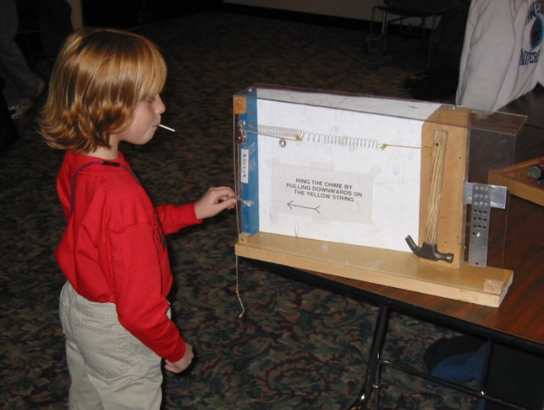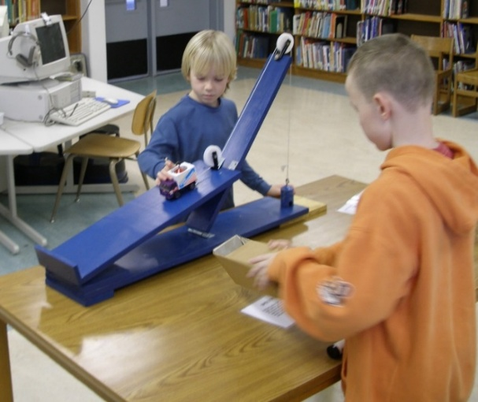

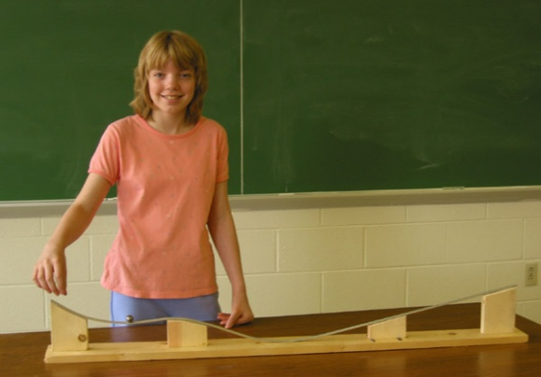

In a classroom

**APPLICATION FORM FOR THE VISITING PHYSICS PETTING ZOO**

*The Visiting Physics Petting Zoo is described at* <https://www.pa.uky.edu/sciworks/travelzoo/> .

Name:

email address:

telephone number:

School:

Mailing address:

Please explain how you plan to use the Physics Petting Zoo: the nature of the events and likely number of participants.

If there are specific dates, please specify these.

Please return this form to Kwok-Wai Ng ( kwng@uky.edu ) or Yuanyuan Su ( [ysu262@g.uky.edu](mailto:ysu262@g.uky.edu) ) with the subject line “Physics Petting Zoo Application.” If you have questions, write to [jstraley@uky.edu](mailto:jstraley@uky.edu) .

Conditions: There is no charge for this; the round trip is prepaid. It is understood that things break or go missing; however, please try to take care of the Physics Petting Zoo. Please return it “within two weeks” or on an agreed schedule.

USER AGREEMENT for the VISITING PHYSICS PETTING ZOO

1. There is no charge for this; the round trip is prepaid.

2. We will agree how long the Visiting Physics Petting Zoo visits your school. You will return the Zoo on time.

3. The Visiting Physics Petting Zoo will always have adult supervision. It’s pretty hard to hurt yourself with items in the Zoo, but kids will try.

4. Please try to take care of the Visiting Physics Petting Zoo.