This treatment of random functions of time follows Davenport and Root, “Random Signals and Noise”, IEEE PRESS.

The autocorrelation function, $R\left[x\right],$ of a random function, $X\left[t\right],$ is

$R_{X}\left[u\right]=\frac{1}{2T}\int_{-T}^{T}{X\left[t\right]X\left|t+u\right|}dt$.

The mean square noise in *X* is $R_{X}\left[0\right]$.

The spectral density is the Fourier transform of the autocorrelation function.

$S_{x}\left[ω\right]=\int_{-∞}^{+∞}{R_{X}\left[u\right]e^{j ω u}du}$.

If a linear operator *G*,



is applied to *X* the spectral density of *Y* is $S_{y}\left[ω\right]=S_{x}\left[ω\right]{\left|G\left[ω\right]\right|}^{2}$. The frequency-domain operator *G*[**] is *g* applied to *Exp*[*j* ** *t*]. This relationship allows one to calculate the mean square noise in *Y*.

$R_{Y}\left[0\right]=\int_{-∞}^{+∞}{S_{x}\left[ω\right]{\left|G\left[ω\right]\right|}^{2}}$.

Mark calculated the spectral density for r38085.

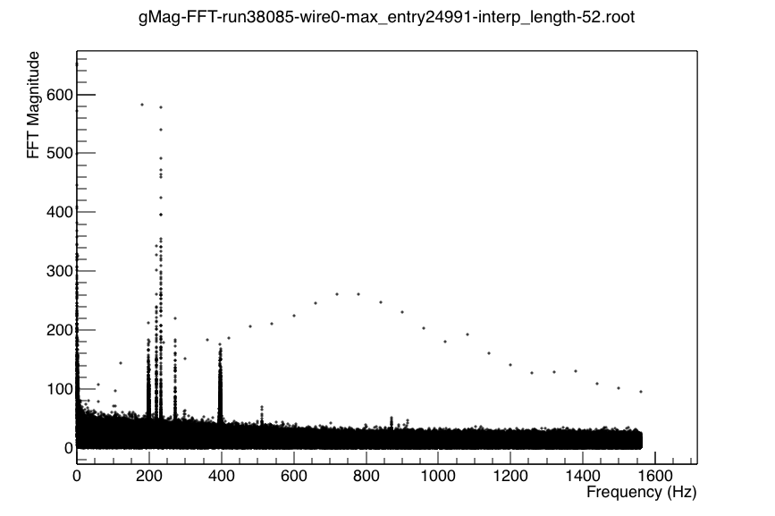

There is a flat component from 0 to 1550 Hz, a strong ** function at 390 Hz, and a group of ** functions between 200 and 270 Hz. We are interested in integrating the detector signal over some time interval within each frame. The time-domain operator is



The frequency domain operator is



For *T*=9 m s,



has zeros at 220 Hz and a maximum at 400 Hz.



For *T*=10 m s,



has zeros at 200 Hz and 400 Hz.



It may be possible to reduce the noise in the detector yield summed over some time interval by adjusting the length of the time interval. The contribution of the flat shot noise contribution is proportional to



The contributions of the ** functions near 200 Hz and at 400 Hz depend on the integration time differently. The best integration time for 400 Hz is 10 m s while the best integration time for the group centered at 220 Hz is 9 m s. In order to determine the best integration width, a numerical study will be required. It seems that it will not be possible to dramatically reduce the noise by tuning the integration time.

It is possible to distinguish between electronic noise and noise from wire vibrations. I searched Mark’s spectral density plots for Run 38085 to see if the same frequencies appeared in different wires. Wire vibrations would have different frequencies in different wires, and electronic noise would have the same frequencies in different wires. Here are the frequencies for run 38085.

|  |  |  |  |  |  |  |  |  |  |
| --- | --- | --- | --- | --- | --- | --- | --- | --- | --- |
| Wire#/f |  |  |  |  |  |  |  |  |  |
| 1 | 200 B | 220 | 232 D | 247 | 250 |  |  |  |  |
| 2 | 204 | 222 B | 229 | 234 | 243 | 244 | 246 | 250 | 262 |
| 3 | 230 | 234 | 242 | 244 | 246 | 261 B |  |  |  |
| 4 | 228 | 234 M | 243BM | 262 | 268 |  |  |  |  |

B Broad

D Doublet

M Multiplet

There is no strong evidence of the same frequency appearing in several wires.

The next picture from Kabir’s thesis shows the false asymmetry for wires.

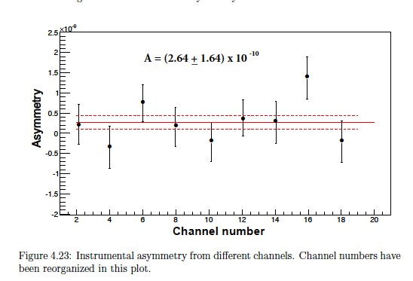

The observed instrumental asymmetry (AInst=(2.6 ± 1.6) 10-10) has an 11% chance of occurring by chance. I will find out from Kabir how to interpret the above noise.

The next figure gives Kabir’s analysis of the weighted false asymmetry from Tuesday runs.

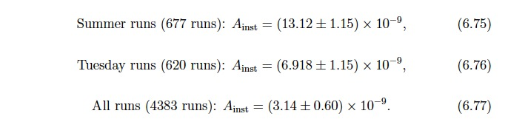

The direct approach would be to subtract the Tuesday run asymmetry from the physics asymmetry and add the errors in quadrature.

APV=(1.0 ±1.0)10 -8 – (0.7 ±0.15)10 -8 = (0.3 ±1.0)10 -8.

How accurately can we test for false asymmetries by analyzing the dropped pulse frames in the beam on data? Assume that there are 6 times more production runs than Tuesday runs. There are 600 times fewer dropped pulse data than beam on data.



It may be possible to get a statistical uncertainty in the false asymmetry comparable to the statistical uncertainty in the PV asymmetry by analyzing the dropped pulse data in the production runs.

**Path Forward:**

We have working hypothesizes:

1. There are unrelated sources of noise in the PV asymmetry from ADC electronic noise, preamp electronic noise, shot noise from neutron statistics, and narrow-band noise from wire vibrations driven by mechanical vibrations of the floor. ADC noise < preamp noise < neutron statistics ~ vibration noise.
2. There may be a systematic uncertainty from coupling of the spin-flipper state into the preamps or ADC’s.
3. There is no systematic uncertainty introduced by vibrations. The argument for this assumption is that the spin-flipper state is plausibly coupled into the preamps and ADC’s by ground loops, but there is no plausible mechanism for the weak spin-state signal to drive vibrations of the floor. This assumption is not limiting because the available methods of determining false asymmetries determine a sum of contributions from vibrations and electronic couplings.

We can determine the false asymmetry from Tuesday runs, beam off runs during production running, and dropped pulse data during production running.

My proposal is

1. Analyze a few runs each of beam-on and beam off data and determine the RMS noise for time windows of different widths. Window centered and 10% width scans. Choose an optimal width for subsequent analysis (below)
2. Group the production runs into 1 week groups interleaving the Tuesday runs.
3. Determine the PV asymmetries for the 1 week groups
4. and for the interleaved Tuesday runs
5. Determine the false PV asymmetries for the beam-off data during production
6. Determine the false asymmetries from 1/600 dropped-pulse data.
7. Look at the above results on a common time axis.
8. If we understand what we see, make subtractions D, E, and F from C.
9. Determine corrected PV asymmetries and their uncertainties. Note that even if the uncertainties in the false asymmetries are comparable to the statistical uncertainty in the PV asymmetry as in F., we still get a very interesting value for the PV asymmetry.