PHY 520G Group Project
Fourier analysis and dispersion
By David Bowles, David Mathews, Jianxiao Wu
Ever since Joseph Fourier started to investigate the application of Fourier series to the problems of heat transfer and vibration, the academia of mathematics and physics has been cheering for its elegance to simplify the studies by treating a function as the superposition of the trigonometric functions. In today’s academia and engineering fields, Fourier analysis is frequently used to decompose a function into oscillatory components, while the Fourier transform solutions have shown insights into numerous fields of study. This paper focuses specifically on the process of Fourier analysis and its influence in the dispersion relations.

Conceptual Idea of Fourier Transform
Fourier transform, in essence, transforms a continuous function of time into a continuous function of frequency, creating a frequency distribution, with the form of a Gaussian curve. Such process can also be reversed, shown as the following. Let $F(f)$ be a function of frequency and $f(t)$ a function of time. Notice that F and f are different coefficients representing different amplitudes. Then:
$$F\left(f\right)=\int_{-∞}^{∞}{f\left(t\right)•e^{-i2πft}dt}$$
And vice versa:
$$f\left(t\right)=\int_{-∞}^{∞}{F\left(f\right)•e^{-i2πft}df}$$
The graphical representation of such transform is:
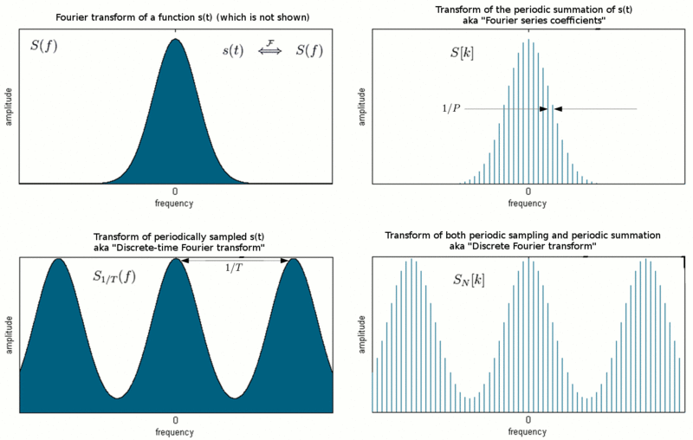
Source: https://en.wikipedia.org/wiki/Fourier_analysis#Interpretation_in_terms_of_time_and_frequency, Wikipedia, Fourier analysis.

Our Project
The above example encompasses the Fourier transform in the energy space, which has the general form of:
$$E=ωħ, with \hat{E}=-iħ\frac{∂}{∂t}$$
Where $ω$ is the angular frequency.
Although our project was modeled based in the momentum space, it is also able to output the correct Fourier transform wave forms in the energy space, due to the Heisenberg Uncertainty principle. The equivalence of the above equation in the momentum space is:
$$P=Kħ, with \hat{P}=iħ\frac{∂}{∂x}$$
Where K is the planar frequency.
We start with: $\hat{f}\left(K\right)=\int{dxe^{-iKx}f\left(x\right)}$, and its inverse Fourier transform is: $f\left(x\right)=\int{dKe^{iKx-iω(K)t}\hat{f}(K)}$. We can clean this up a little and make it: $f\left(x\right)=\int{dKe^{i(Kx-ω(K)t}\hat{f}(K)}$. To get a general solution, we can Taylor expand both K and $ω(k)$ about K₀:
$$K=K_{0}+(K-K_{0})$$
$$ω\left(K\right)=ω\left(K_{0}\right)+\frac{dω}{dK}\left(K-K_{0}\right)+\frac{d^{2}ω}{dK^{2}}\frac{{\left(K-K_{0}\right)}^{2}}{2}+…$$
Where $ω\left(K_{0}\right)$ is the phase velocity, $\frac{dω}{dK}$ is the group velocity, and $\frac{d^{2}ω}{dK^{2}}$ is the dispersive rate. It is also worth mentioning that $ω=\frac{ω{}_{1}+ω_{2}}{2} with ∆ω=\frac{ω_{1}-ω_{2}}{2}$, and $K=\frac{K_{1}+K_{2}}{2} with ∆K=\frac{K_{1}-K_{2}}{2}.$Our equation $f\left(x\right)=\int{dKe^{i(Kx-ω(K)t}\hat{f}\left(K\right)}$ now turns into
$$f\left(x\right)=\int{dK\hat{f}\left(k\right)e^{i\left(Kx-t\left(ω\left(K_{0}\right)+\frac{dω}{dK}\left(K-K_{0}\right)+\frac{d^{2}ω}{dK^{2}}\frac{{\left(K-K_{0}\right)}^{2}}{2}\right)\right)}}.$$
If we simplify it a little, it becomes:
$$f\left(x\right)=e^{\left(K_{0}x-ω\left(K_{0}\right)t\right)i}\int{dK\hat{f}\left(k\right)e^{i\left((K-K_{0})x-t\left(ω\left(K_{0}\right)+\frac{dω}{dK}\left(K-K_{0}\right)+\frac{d^{2}ω}{dK^{2}}\frac{{\left(K-K_{0}\right)}^{2}}{2}\right)\right)}}$$
Where $\hat{f}\left(k\right)=e^{-γ{\left(K-K_{0}\right)}^{2}}$, $γ$ determines the certainty of a measurement in K space – it controls the spread of the wave functions.
Let’s further simplify the equation and:
$$\left\{\begin{aligned}α=\frac{dω}{dK} \\ β=\frac{d^{2}ω}{dK^{2}}\end{aligned}\right.$$
$$f\left(x\right)=e^{{(K}_{0}x-ω\left(K_{0}\right)t)i}\int{e^{-γ{\left(K-K_{0}\right)}^{2}}e^{i[\left(K-K_{0}\right)x-t(α\left(K-K_{0}\right)+β\frac{{\left(K-K_{0}\right)}^{2}}{2}]}dK}$$
Let $q=K-K_{0}$, and the sum of the above exponents is:
$$-γq^{2}+i(qx-tαq-t\frac{β}{2}q^{2})$$
We can complete the square:
$$=-q^{2}\left(γ+\frac{iβt}{2}\right)+\left(ix-ita\right)q$$
$$=-(γ+\frac{iβt}{2})[q^{2}-\frac{(ix-itα)}{(γ+\frac{iβt}{2})}q$$
$$=-(γ+\frac{iβt}{2})[q^{2}-\frac{\left(ix-tα\right)}{\left(γ+\frac{iβt}{2}\right)}q+{\left[\frac{\left(ix-itα\right)}{2\left(γ+\frac{iβt}{2}\right)}\right]}^{2}-{\left[\frac{\left(ix-itα\right)}{2\left(γ+\frac{iβt}{2}\right)}\right]}^{2}]$$
$$=-\left(γ+\frac{iβt}{2}\right){\left[q-\frac{\left(ix-itα\right)}{2\left(γ+\frac{iβt}{2}\right)}\right]}^{2}+\frac{{\left(ix-itα\right)}^{2}}{4\left(γ+\frac{iβt}{2}\right)}$$
Since $\frac{{\left(ix-itα\right)}^{2}}{2\left(γ+\frac{iβt}{2}\right)}=\frac{i(x-tα)(2γi(x-tα)}{4γ-β^{2}t^{2}}=\frac{βt\left(x-tα\right)+2γi(x-tα)}{4γ^{2}-β^{2}t^{2}}$,
$f\left(x\right)=\frac{e^{i\left(K_{0}x-ω\left(K_{0}\right)t\right)}e^{-\left[\frac{{\left(x-tα\right)}^{2}}{4δ+2iβt}\right]}}{2π}\int_{-∞}^{∞}{e^{-(γ+\frac{iβt}{2}){\left[q-\frac{βt\left(x-tα\right)+2γi(x-tα)}{4γ^{2}-β^{2}t^{2}}\right]}^{2}}dq}$.
Let $u=q-\frac{βt\left(x-tα\right)+2γi(x-tα)}{4γ^{2}-β^{2}t^{2}}$, and the integral becomes $\int_{-∞}^{∞}{e^{-\left(γ+\frac{iβt}{2}\right)u^{2}}dq}$. We can use separation of variables to solve it. Let: $\left\{\begin{aligned}v=\sqrt{μ}u \\ dv=\sqrt{μ}du\end{aligned}\right.$, and integral becomes $\frac{1}{\sqrt{u}}\int_{-∞}^{∞}{e^{-v^{2}}dv=\sqrt{\frac{π}{μ}}}$, where $μ=γ+\frac{iβt}{2}$. Finally:
$$f\left(x\right)=\frac{e^{i\left(K_{0}x-ω\left(K_{0}\right)t\right)}e^{-\left[\frac{{\left(x-tα\right)}^{2}}{4δ+2iβt}\right]}}{2\sqrt{γ+\frac{iβt}{2}}\sqrt{π}}$$

Discussion
The final equation $f\left(x\right)=\frac{e^{i\left(K_{0}x-ω\left(K_{0}\right)t\right)}e^{-\left[\frac{{\left(x-tα\right)}^{2}}{4δ+2iβt}\right]}}{2\sqrt{γ+\frac{iβt}{2}}\sqrt{π}}$ is the Fourier transform from the momentum space to the position space. It breaks down the momentum function into super position of series of position functions. We suspected that when completing our last integral $\int_{-∞}^{∞}{e^{-\left(γ+\frac{iβt}{2}\right)u^{2}}dq}$, we included the term $μ=γ+\frac{iβt}{2}$, which means that if we take a finite region Ω, and take the direction of integral as following:

IV
III

I
II
-M
M

Notice that the roman numerals represent the integrals on the surface of the rectangular box, and the direction of these integrals are labeled on the box itself. Because $e^{-u^{2}}$is a well-behaved function, meaning it is an analytic function and it dies off to zero sufficiently quick taking the bounds with contours added to zero at infinity. Therefore: $\lim_{M-∞}{(\int{III}+\int{I})=0}$, and $\int{IV=-\int{II}}$. We can also flip the direction of the integral for II and make it integrate in the same direction of IV, which is exactly what Fourier transform does, and it is our applet output.
Applet Program from Wolfram Alpha
u[x_, t_, k0_, a_] :=
1/Sqrt[1 + a*2*I*t]*Exp[-1/4*k0^2]*
Exp[-1/(4*a + I*2*t)*(x - I*k0/2)^2]
v[x_, t_, w_, k_] :=
Cos[k*x - w*t]
Animate[Manipulate[
Plot[{Abs[u[x, t, k0, a]]*v[x, t, w, k],
Abs[u[x, t, k0, a]]}, {x, -60, 60}, Axes -> {True, False},
PlotRange -> {-2, 2}, PlotStyle -> Thick,
PlotLegends -> {"Wave Packet", "Amplitude"}] , {{k, 1,
"Frequency"}, 0, 5}, {{k0, 0, "Group Velocity"}, -3,
3}, {{w, 0, "Phase Velocity"}, -5,
5}, {{a, .5, "Dispersion Rate"}, .1, 2}], {{t, 0, "Time"}, 0, 10}]

